**Logging:**

* The log files get stored in logs directory.
* Catalina.out file stores the log data when we start the server. As below it records all the data about jdk, os name, OS version etc.

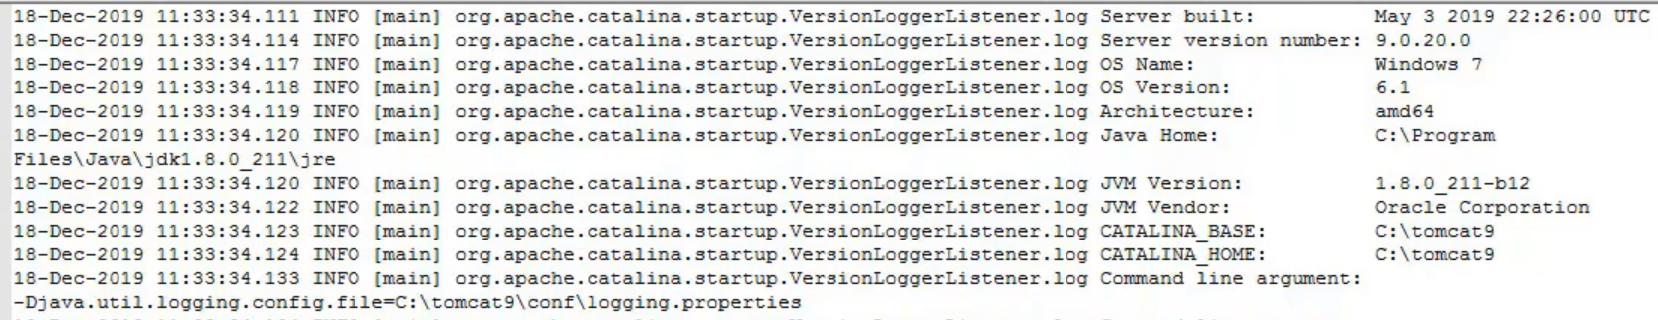

* It starts the listener and other things
* Finally, it loads all the application deployed in tomcat and it gets started as below.

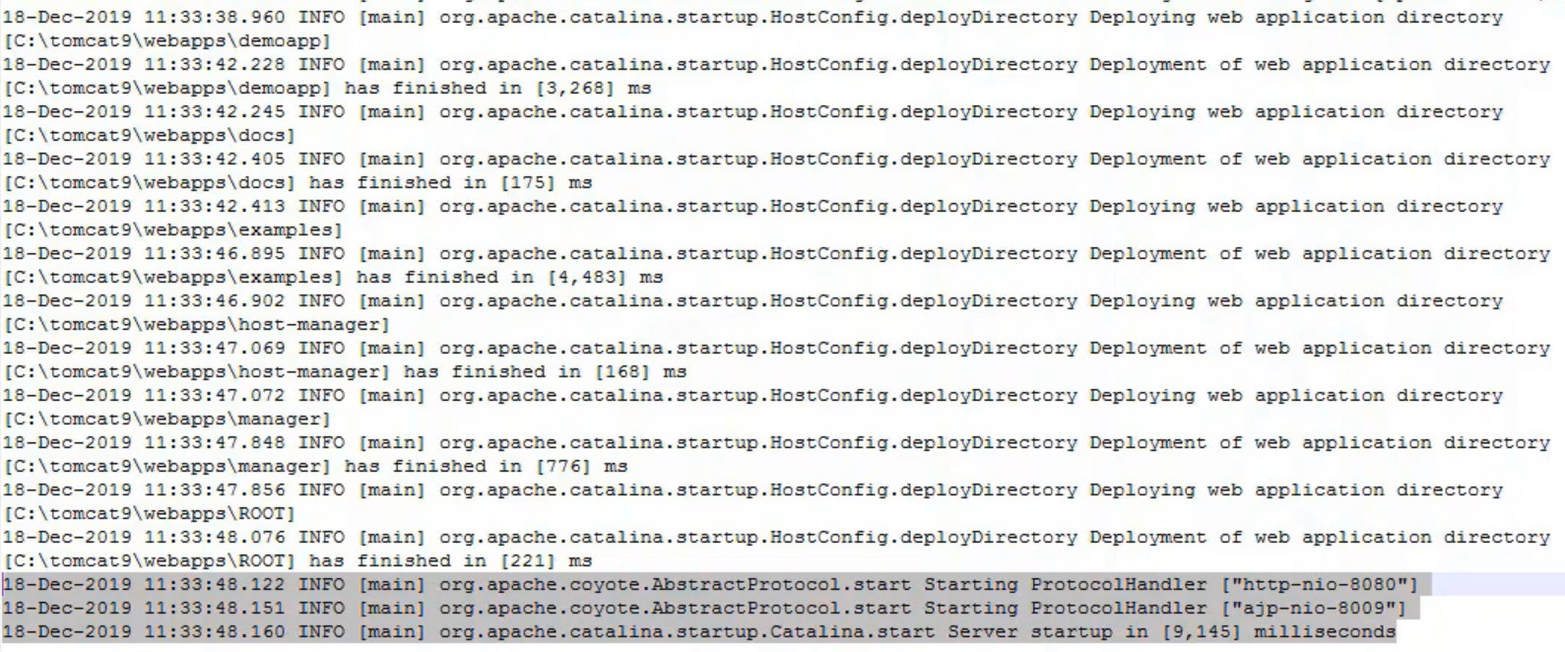

* Whenever we make a connection to tomcat service, that connection details will be logged into localhost-access log files with the client IP as below.



* It logs the client IP, time and date, the request time, protocol, response to the request and how many bytes of data sent from server.
* Tomcat uses a framework “java.util.logging” for logging. It is also called as JULI.
* There are two handlers as well. AsyncFileHandler is to write the logs in text files and ConsoleHandler is to write the logs into console.
* For configuring logging related things. Tomcat uses a file called logging.properties

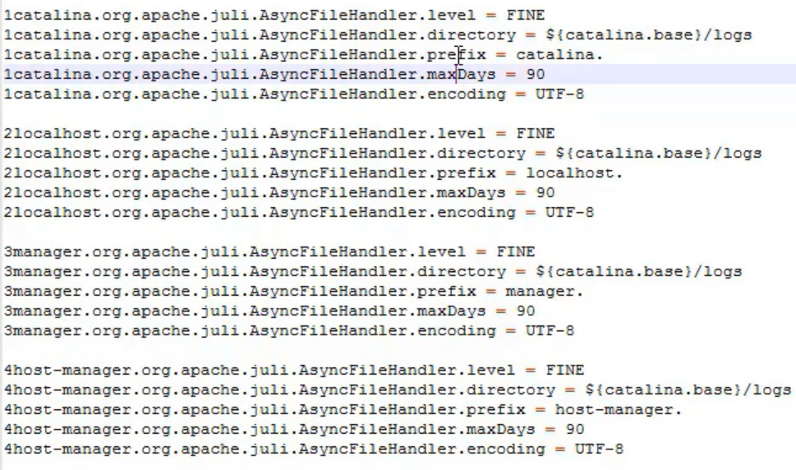

* As above, we can set the loglevel, path to the log directory, prefix for the log files on which name the names should get started with. The date will be appended to the prefix
* Then the retention time till how long the log files should be store in logs directory.
* We can do all these for asynchandler
* We can do the configuration for all the application inside the file as above we have 4 applications along with Catalina

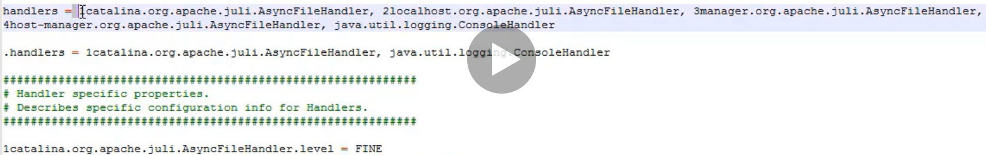

* As above, we can see the fully qualified names for the logging of each application for async handlers.
* As above, 4 asp handlers are running.
* And if we delete manager apps in webapps but not in logging properties. Then the logs files will get created with no data every time we restart the tomcat as below.

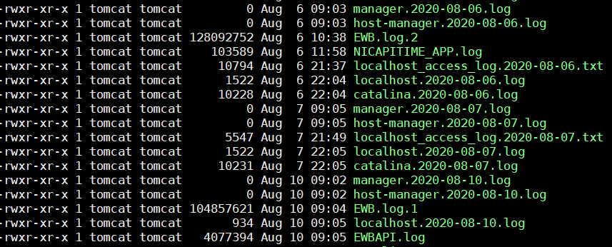

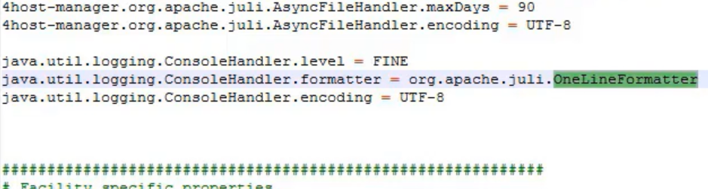

* And for date format in log files, we can change the formatter as above. By default, it comes with OneLineFormatter.
* There are other formatters also. We can use based on the requirement.

**Indepth:**

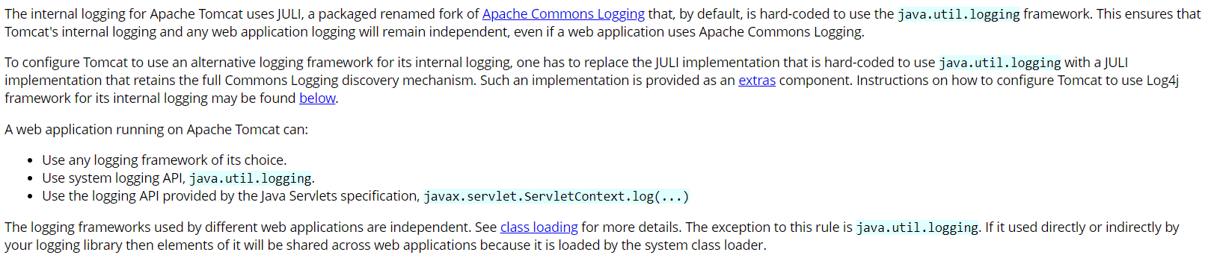

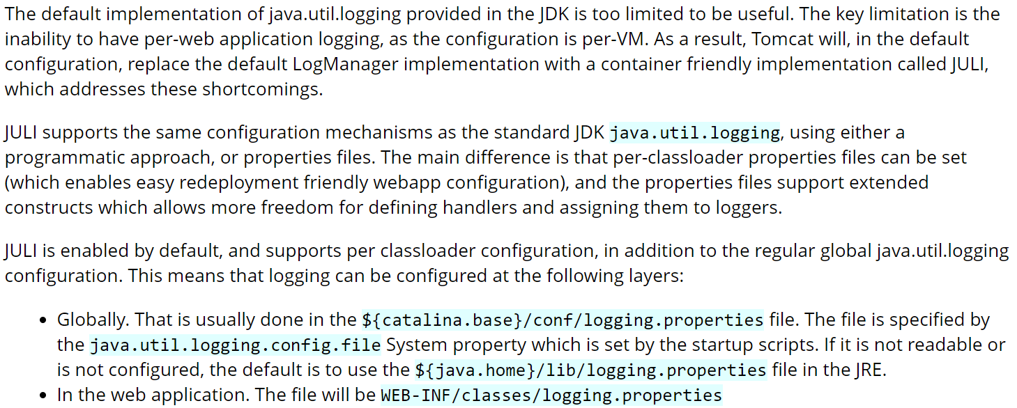

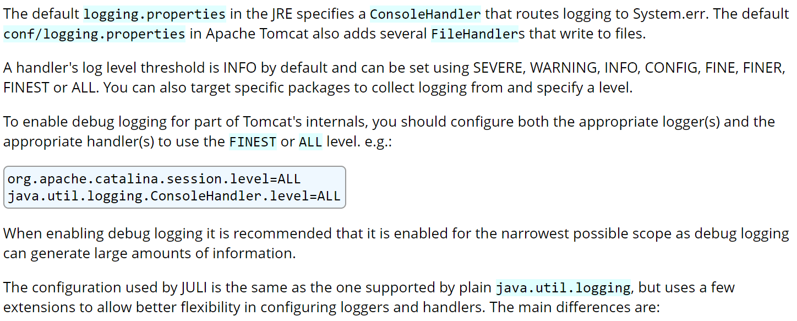

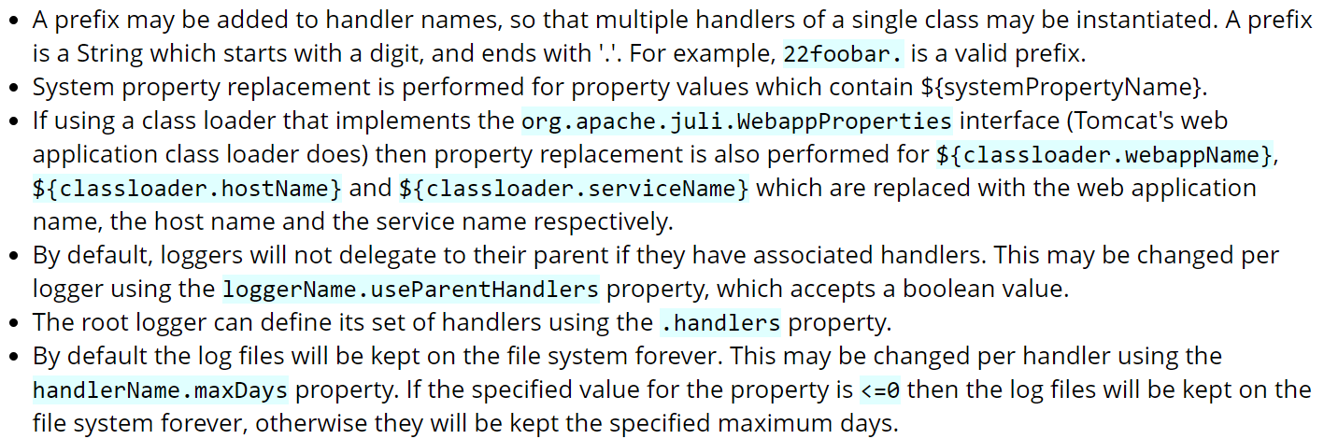

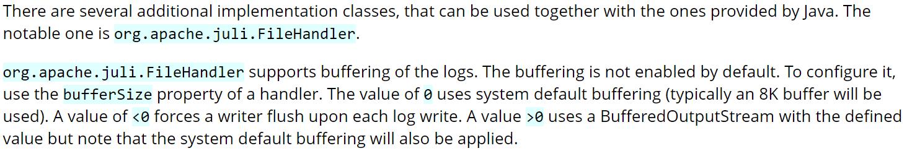

**Using log4j:**

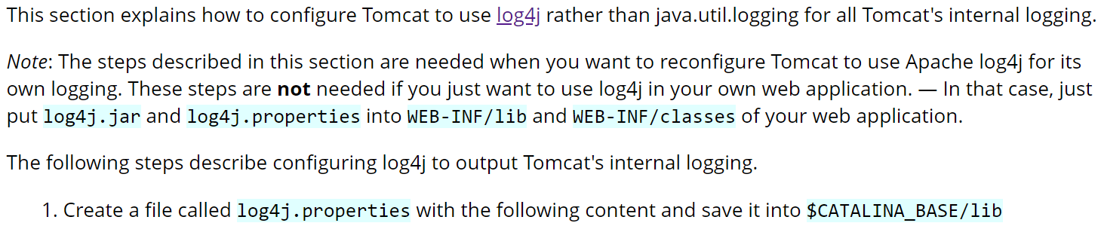



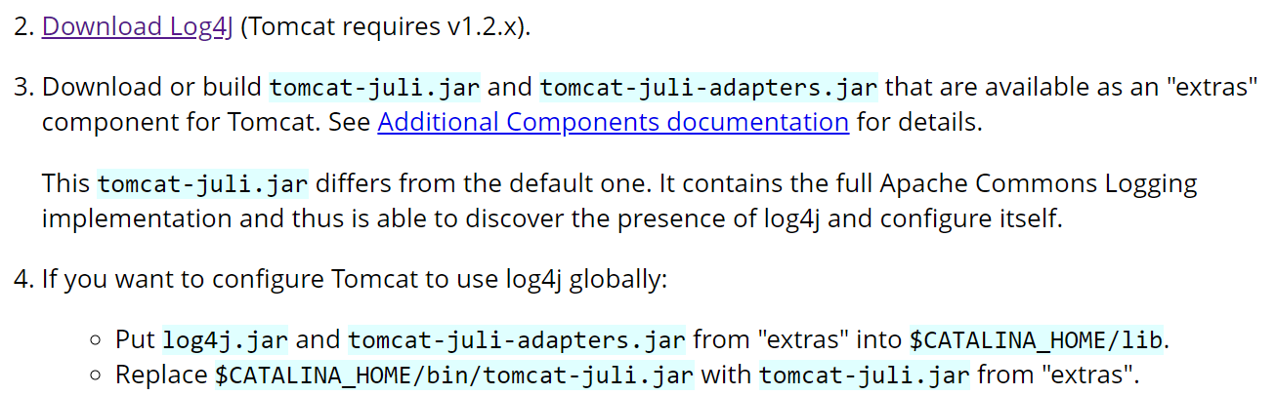

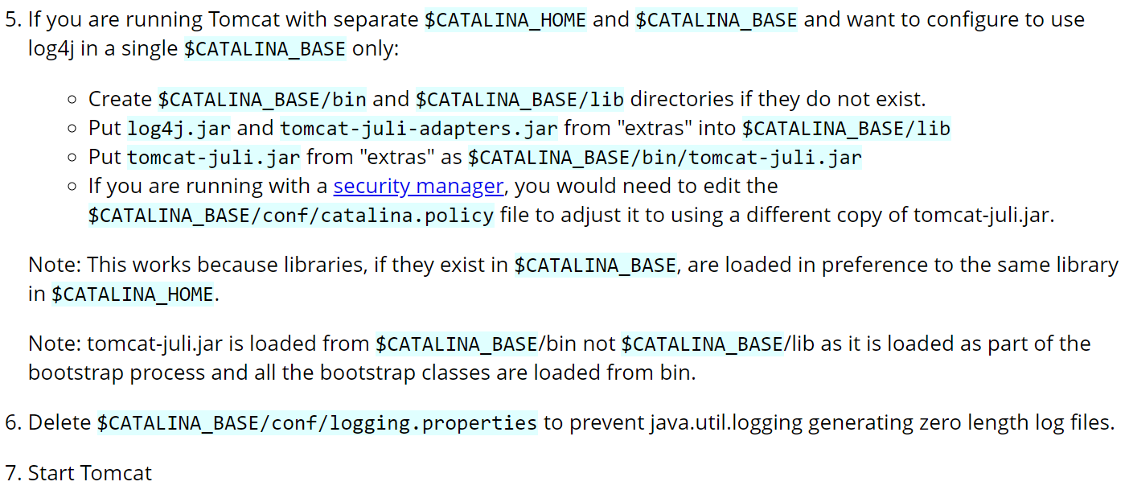

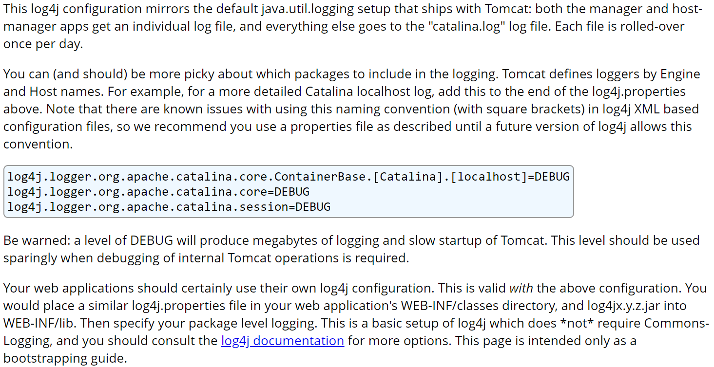

**Another example:**

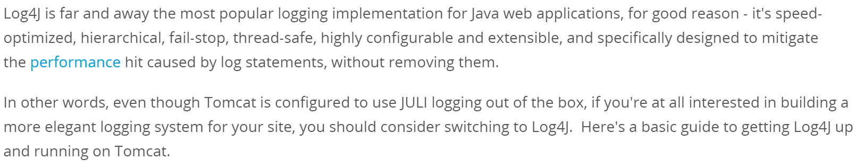

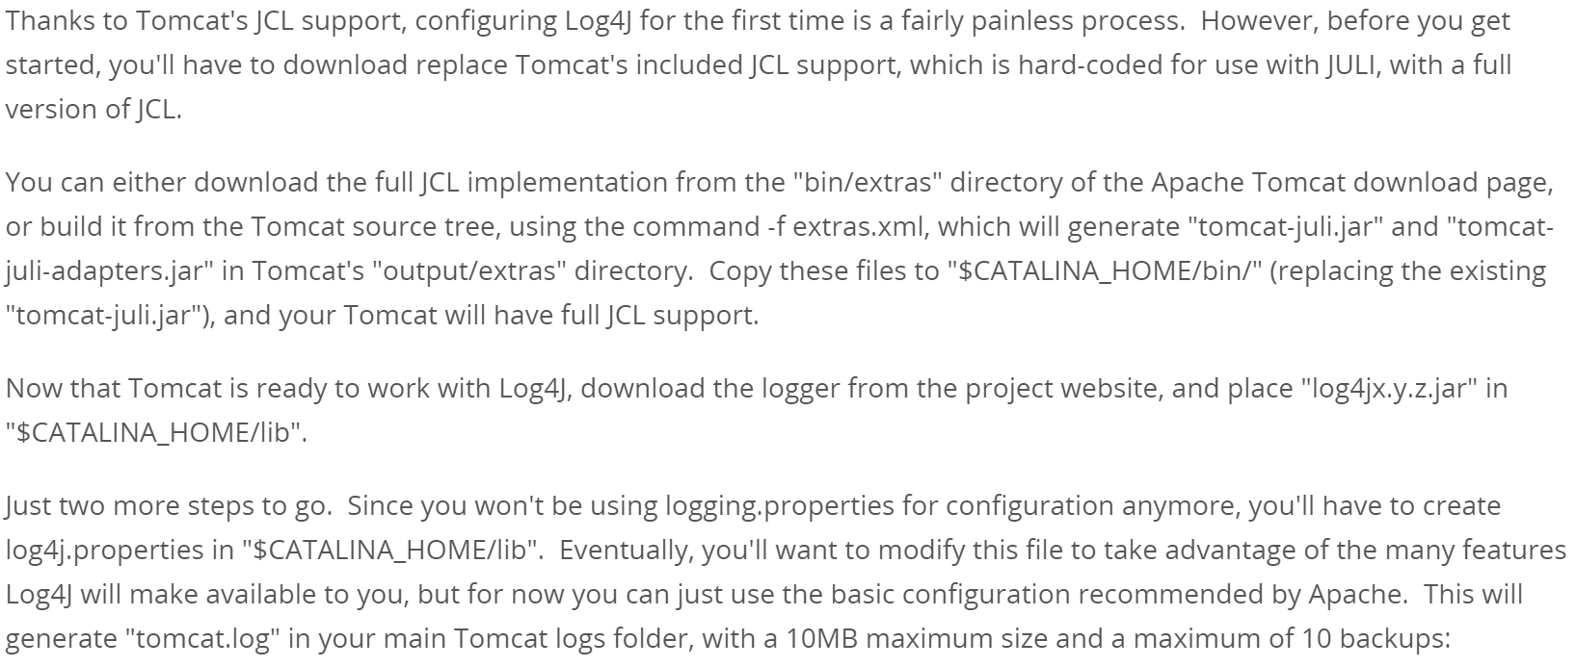

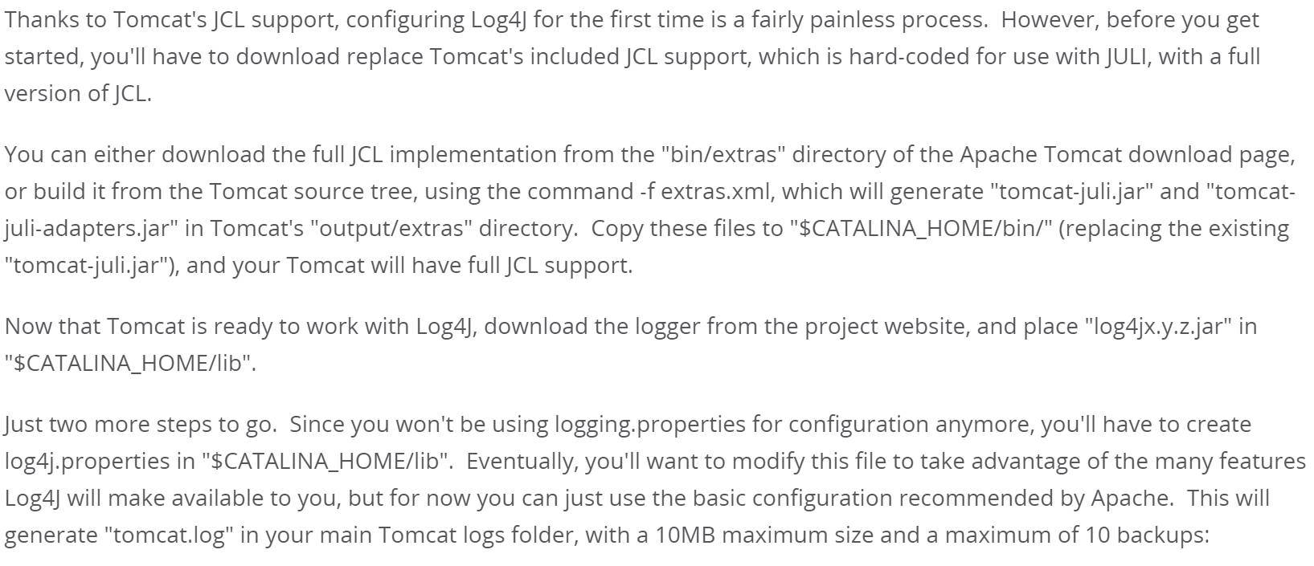

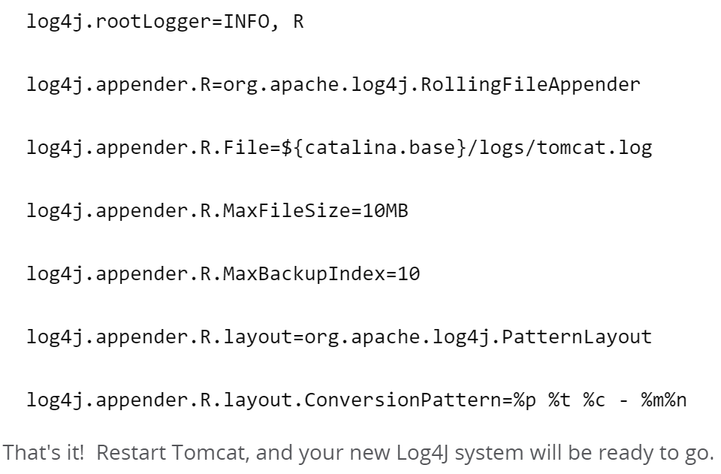

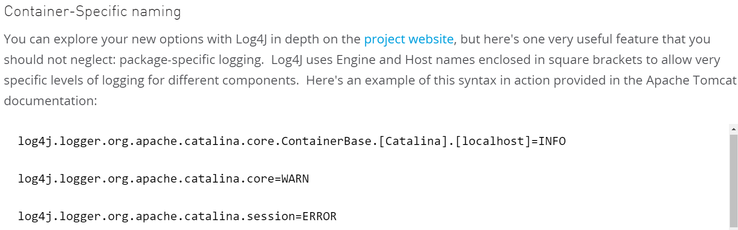

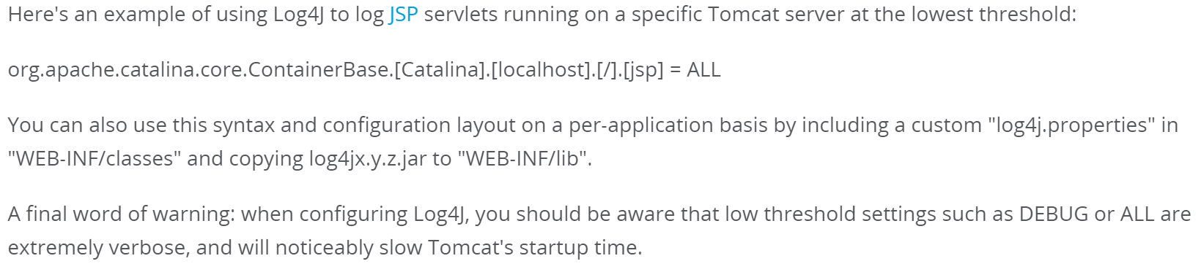

**Some parameters:**

* **“RollingFileAppender”** in log4j is used to set the logfile size and all as below.

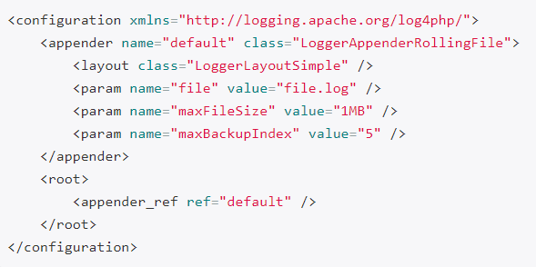

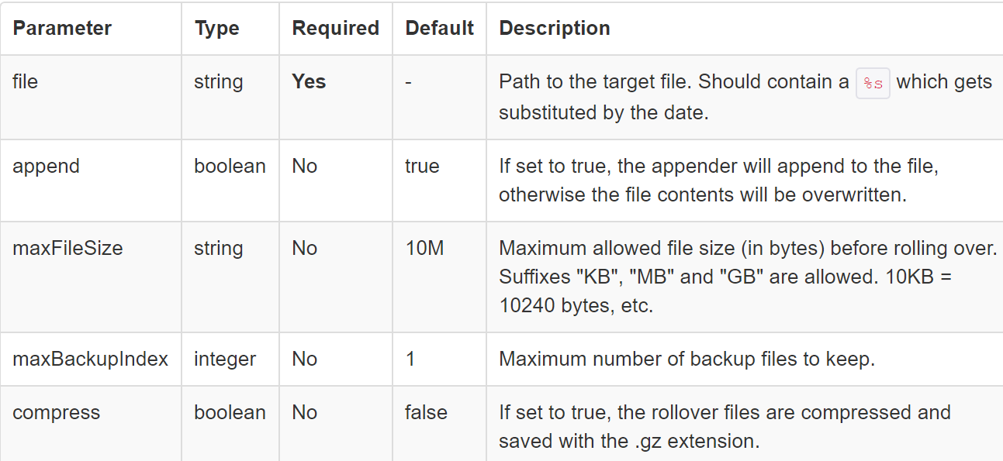

* By default, the log files will get created with filename.txt.1 and filename.txt.2 and so on.
* If we want to change it to like filename1.txt and filename2.txt and so on, then we need to configure log4j as below.

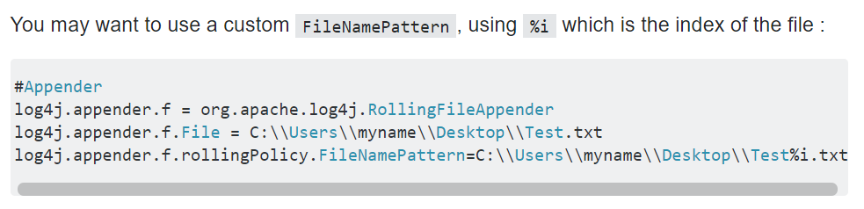

**From tutorialpoint for very in-depth knowledge:**

<https://www.tutorialspoint.com/log4j/log4j_logging_files.htm>